Advanced Computer Networks – PCS223
Assignment 4
Name – Writick Parui
Subgroup – CS4
Roll No. – 8025320111
Q.1 Create a pool on the DHCP Server router named 'xyz' and
follow all the requirements.
• Client should use DNS server IP address: 1.2.3.4
• Client should use network 192.168.10.0/24
• Client should renew IP address after every 3 hours
• Router should not respond to BOOTP
• Client should obtain IP from DHCP server
Router Configuration:
enable
configure terminal
ip dhcp pool xyz
network 192.168.10.0 255.255.255.0
dns-server 1.2.3.4
lease 0 3
no ip bootp server
exit
Interface Configuration:
interface fa0/0
ip address 192.168.10.1 255.255.255.0
no shutdown
Client Configuration:
Set PC IP configuration to DHCP mode.
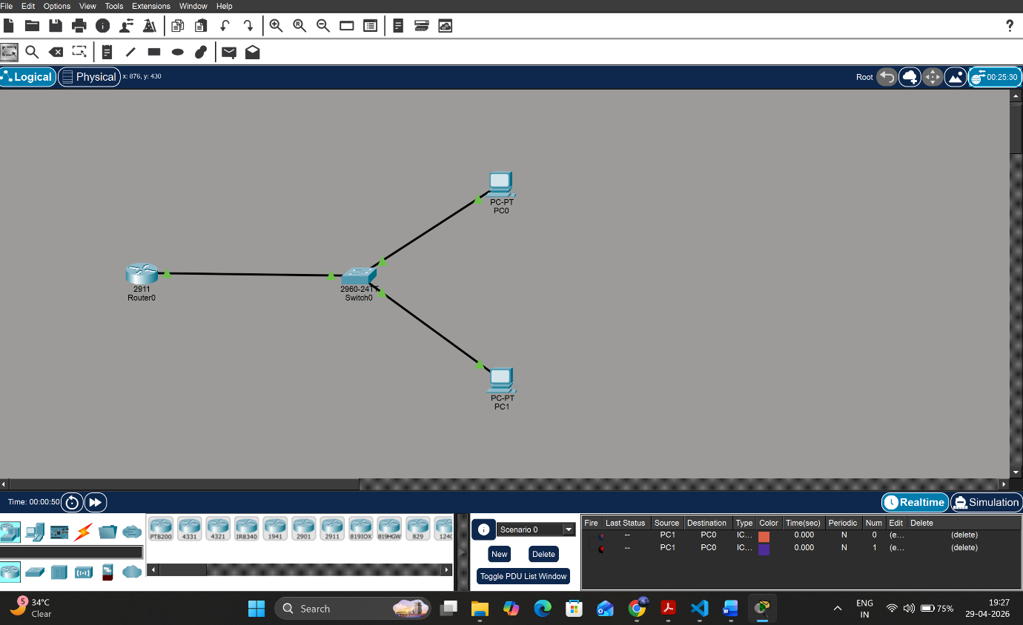

Verification:
• ipconfig ® Should receive IP in range 192.168.10.x
• ping 192.168.10.1 ® Successful reply
Conclusion:
Successfully configured DHCP server on router with pool name 'xyz'. Clients dynamically received
IP address, DNS, and gateway settings. BOOTP service was disabled and connectivity was
verified.

